Designing, Building and  Retrofitting with UHPFRC  Menton – October 21 - 23, 2024  Post-conference tour (UHPFRC realizations): October 23, 2024  Name: ………………………………………First name: …………………………  Title: ………………………………………………………………………………………….  Company: ………………………………………………………………………………..…  Address: ………………………………………………………………………………….  ………………………………………………………..……………………………………………  Tel : ……………………………… E-mail: ……………………………………  ◻ I am interested in Menton UHPFRC 2024, and I would like to have more information on :  ◻ registration ◻ exhibition  ◻ I intend to present an abstract  Title:………………………………………………………………………  ◻ I intend to present a poster  Deadlines | …..…………………………………………………………………………………………………………………………………………… | GENERAL INFORMATION  The symposium will be held in the Palais de l’Europe in the city of Menton (close to Nice) from October 21 to 23, 2024. A technical visit of UHPFRC applications in Monaco and on The French Riviera will be organized during the symposium. The proceedings will be edited in digital format by AFGC.  Official language is English.  Call for papers  Selected papers will be presented on the basis of relevance and originality to stimulate knowledge advances and UHPFRC applications. To contribute, send a two-page abstract to UHPFRC 2024 secretariat (afgc@afgc.asso.fr) before November 15, 2023.  Exhibition  A products and services exhibition will be open during the conference. Contact: afgc@afgc.asso.fr  Organizing committee  Chairman: Jacques RESPLENDINO (JB Pastor & Fils – AFGC)  Scientific committee  Chairman: François TOUTLEMONDE (Université Gustave Eiffel) assisted by more than 50 experts of nearly 30 different nationalities.  Mareterra © SAM Anse du Portier |  | 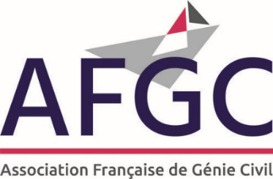  UHPFRC 2024  Preliminary invitation  Call for papers  4th International Symposium on Ultra-High Performance Fibre-Reinforced Concrete (UHPFRC)  Designing, Building and Retrofitting with UHPFRC  Menton  October 21 - 23, 2024  Technical tour (UHPFRC realizations)  Monaco and French Riviera        
  Submission of abstracts | November 15, 2023
  Abstracts acceptance | January 15, 2024
  Submission of full-length papers | March 31, 2024
  Full papers delivery | June 30, 2024
  Presentations delivery | October 1st, 2024
  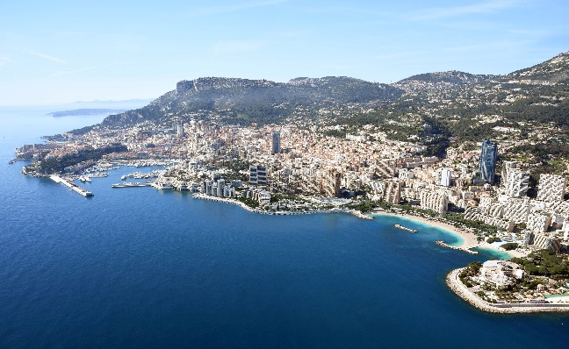

OBJECTIVES  Seven years after the 2017 Ultra-High Performance Fiber Concrete (UHPFRC) conference held in Montpellier, under the auspices of fib and AFGC, focused on the know-how and applications carried out with UHPFRC, it is clear that projects and constructions using UHPRFCs have experienced a marked increase in Europe, in North America and in Asia.  The objective of the 2024 UHPFRC International Symposium organized in Menton by AFGC, under the auspices of RILEM, IABSE, fib and ACI Chapter of Paris, is to update additional experience acquired in the knowledge and use of UHPFRCS:  - design of structures, elements and works  - retrofitting and repair of structures  - industrial realization  - large-scale applications.  The symposium will present the most recent concrete realizations in civil engineering, building and in the field of equipment and infrastructure, in new construction and rehabilitation.  It will deal with regulations and standards developed at the international level to facilitate the design, justify the safety and the reliability of structures.  It will detail the performance offered by these materials towards environment: use in the field of eco-design, saving of resources, durability, reduction of CO2 emissions, life cycle analysis, etc.  The present call for papers is dedicated by AFGC to all participants in the building act, owners, designers, supervisors, construction companies, materials suppliers and members of the concrete industry, engineering offices, architects, laboratories and research centers, academic partners, checkers, who have been involved in UHPFRC realizations. The expected communications, which should clarify the reasons for having chosen UHPFRC (aesthetics, structural performance, durability or environmental characteristics), should emphasize the experience gained and draw lessons for further applications. | anies | THEMES AND TOPICS  The UHPFRC 2024 symposium will be devoted to the presentation of recent achievements on the following topics:  - Applications and achievements in UHPFRC: Civil Engineering and Buildings,  - Codifications, Regulations, Standardizations,  - Environmental aspect: low carbon, saving materials, recycling, eco-design  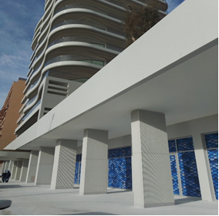  Palais de la Plage - © JBP - J.Resplendino  Symposium Secretariat  Nadget Berrahou-Daoud  AFGC – 42, rue Boissière  F- 75116 Paris  afgc@afgc.asso.fr  Tél. +33 1 85 34 33 18 | ………………………………………………………………………………………………………………………………………………… | AFGC  UHPFRC 2024 Secretariat  Attention to: Nadget BERRAHOU-DAOUD  42, rue Boissière  75116 – PARIS  FRANCE

